HOMEWORK 3-

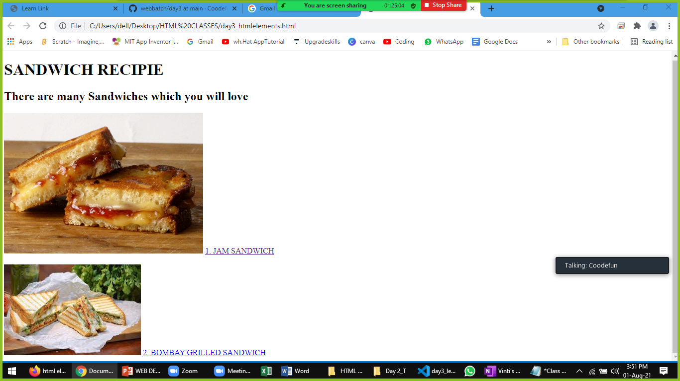

Instructions : Design a page with 5 different type of sandwiches.